**Send an email when a tweet is posted**

You can create a flow that automatically performs one or more actions after it's triggered by an event.

## **Prerequisites**

* An account on [flow.microsoft.com](https://flow.microsoft.com/)
* A Twitter account
* Microsoft Office 365

## **Specify an event to start the flow**

First, you must select the trigger (event) that starts the flow.

1. Sign in to [Power Automate](https://flow.microsoft.com/) by using your organizational account.
2. Select **My flows**.
3. Select **New**, and then select **Automated--from blank**.
4. Under **Choose your flow's trigger**, enter twitter, select the **Twitter - When a new tweet is posted** trigger and select **Create**.

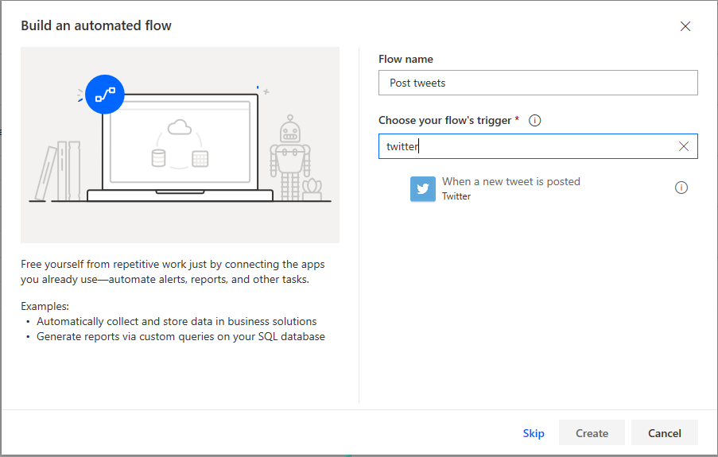

1. If you haven't already connected your Twitter account to Power Automate, select **Sign in to Twitter**, and then enter your credentials.
2. In the **Search text** box, enter the keyword to find.

## **Specify an action**

1. Select **New step**, and in the search field, enter send email, and then select the **Office 365 Outlook - Send an email** action.

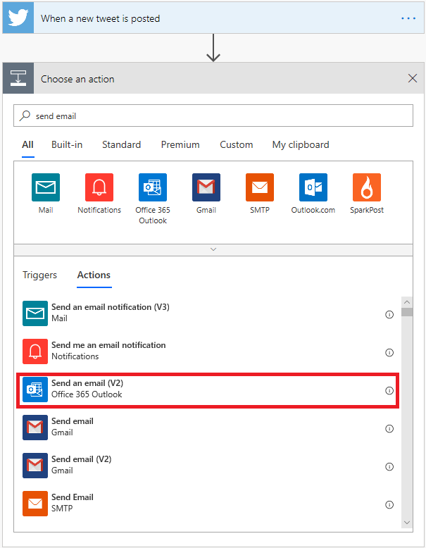

1. If you're prompted to sign in, select the sign-in button, and then enter your credentials.
2. In the **To** field, enter or paste your email address, and then select your name in the list of contacts that appears.
3. In the **Subject** field, enter **New tweet from:** followed by a space.
4. In the list of dynamic content, select the **Tweeted by** token to add a placeholder for it.

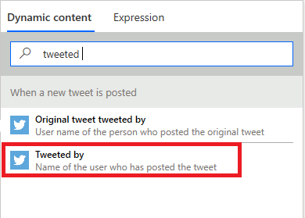

1. Select the **Body** field, and then, in the list of dynamic content, select the **Tweet text** token to add a placeholder for it.
2. Optional: Add more tokens, other content, or both to the body of the email.
3. Select **Save** to save the flow.
4. Post a tweet that includes the keyword that you specified, or wait for someone else to post such a tweet.

Within a minute after the tweet is posted, an email message will notify you of the new tweet.